|  |  |  |
| --- | --- | --- |
|  |  |  |
|  | |
| USER MANUAL | |
|  | |  |

**Edit Student**

**USER MANUAL**

|  |  |
| --- | --- |
| ***Document Name*** | ***Edit Student User Manual*** |
| ***Document number*** | - |
| ***General Description*** | This documented procedure describes how to edit an existing student |
| ***Target Audience*** | Centre Administrator |

DOCUMENT SUMMARY

|  |  |
| --- | --- |
| Subject: | Edit Student User Manual |
| Version: |  |
| Issue Date: | 05/11/2018 |
| Circulation: | Quran Center |
| Prepared by: | Rouaa Sabri |
| Language: | English |
| Status: | Draft |

REVIEW AND APPROVAL

|  |  |
| --- | --- |
| Checked by: | - |
| Approved by: | - |

Table of Contents

1 PURPOSE 1

2 LOGIN 1

3 StudentList Interface 2

3.1 Fetch Student 2

3.2 Edit Student 3

4 LOGOUT 4

1. PURPOSE

This documented procedure describes how to use the student list interface to edit an existing student

1. LOGIN

It can be accessed via URL: <http://quran.alfatehbh.net/sch-student>

The username and password for the user must be entered to access the student list interface

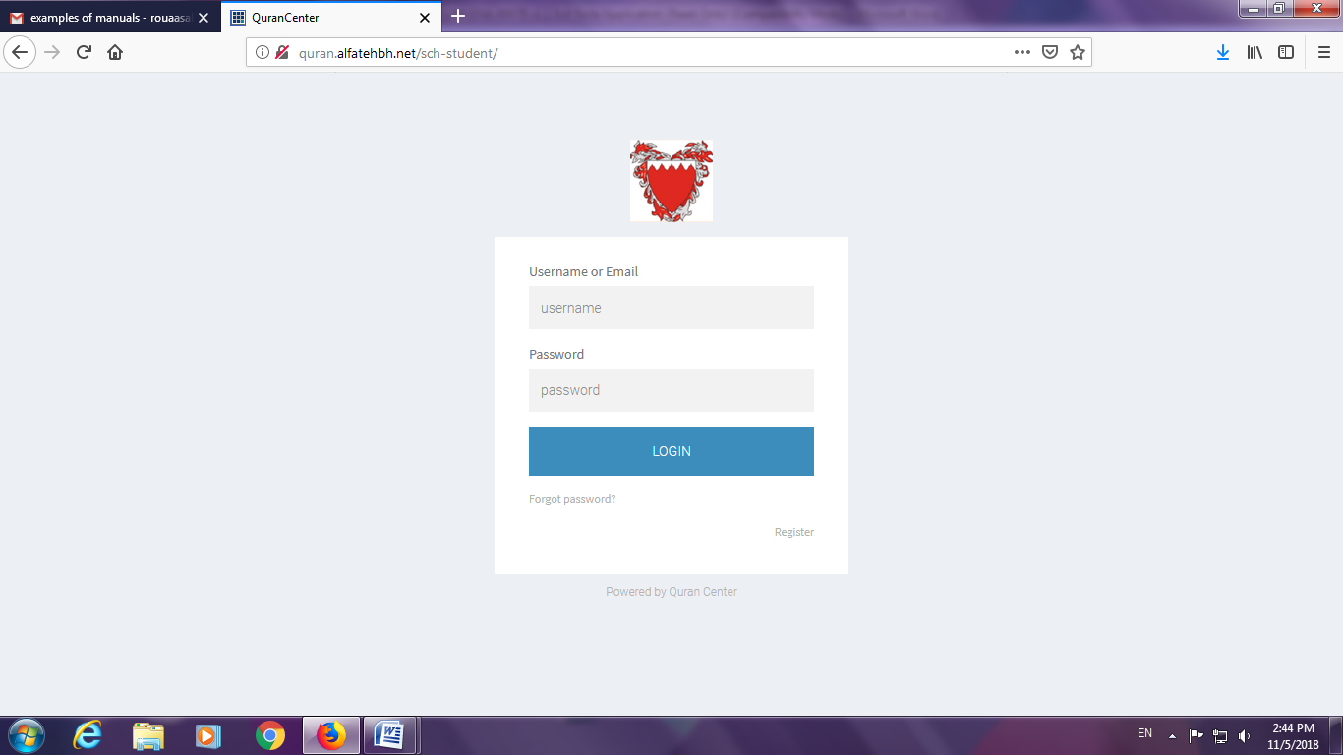

Note: The information to be displayed are based on your user rights.

1. Student List Interface

## Fetch Student

Using the search field , a particular student can be found using their CPR and Name. The students can be shown according to their class or a list of all students from the class filter field.

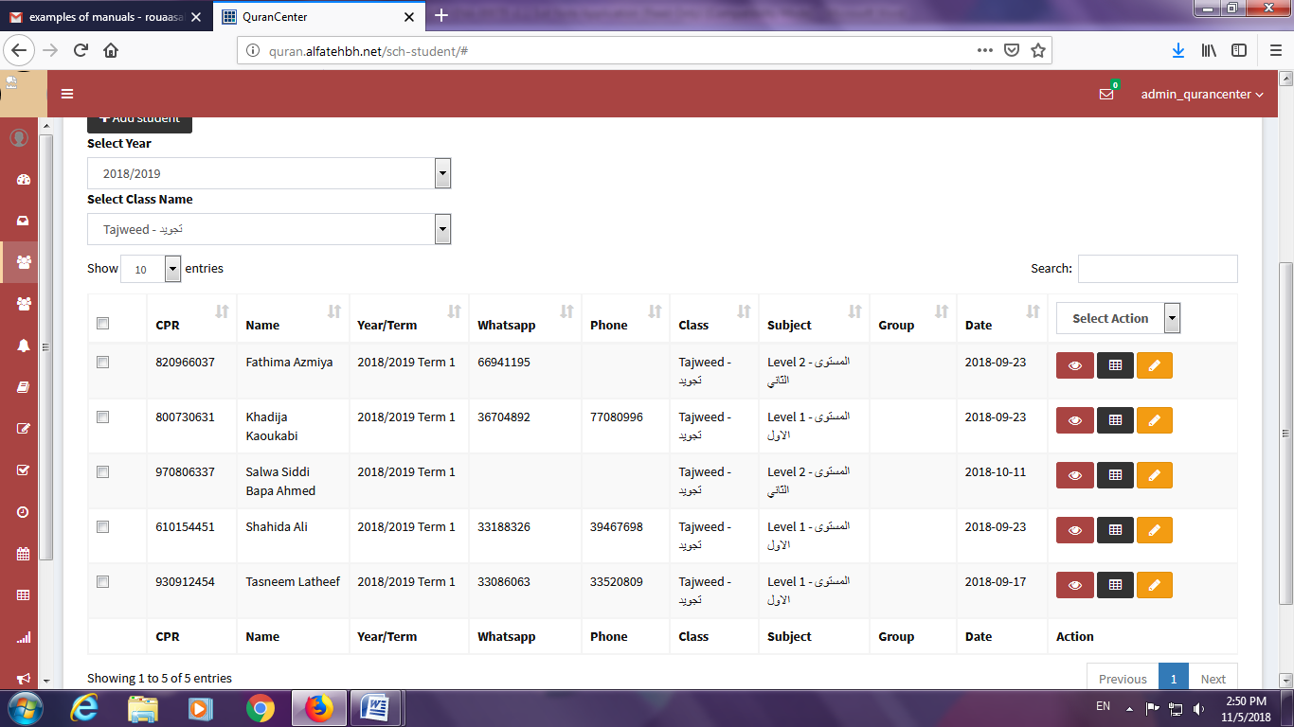

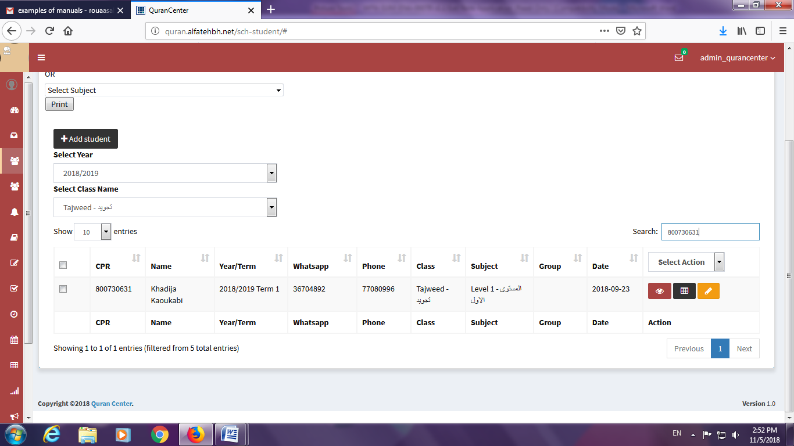

## Edit Student

Using the edit icon 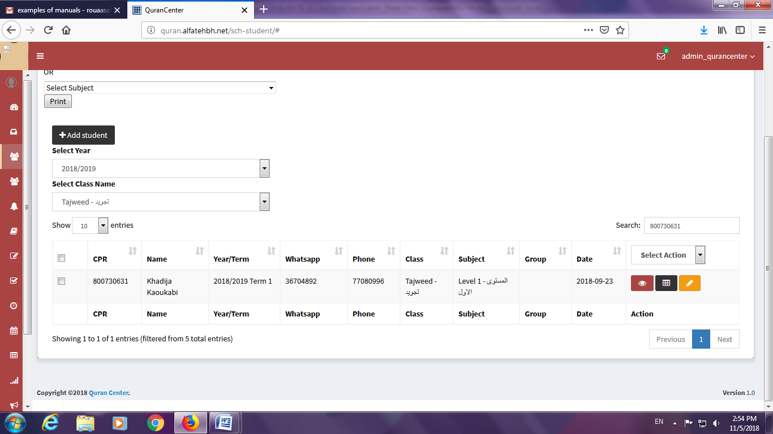from the student list options a form with the student details and classes will be shown. The details can be edited and they will directly updated in the database. The form shows the classes at which the student is currently registered at. To delete or edit that particular class the first select will used. If the student is to be added to a new class a multiple select is available for that purpose. The edit will edit the current record in the database. And adding the new class will create a new record.

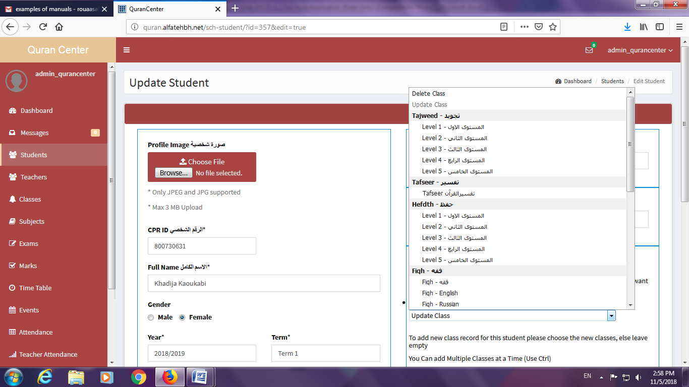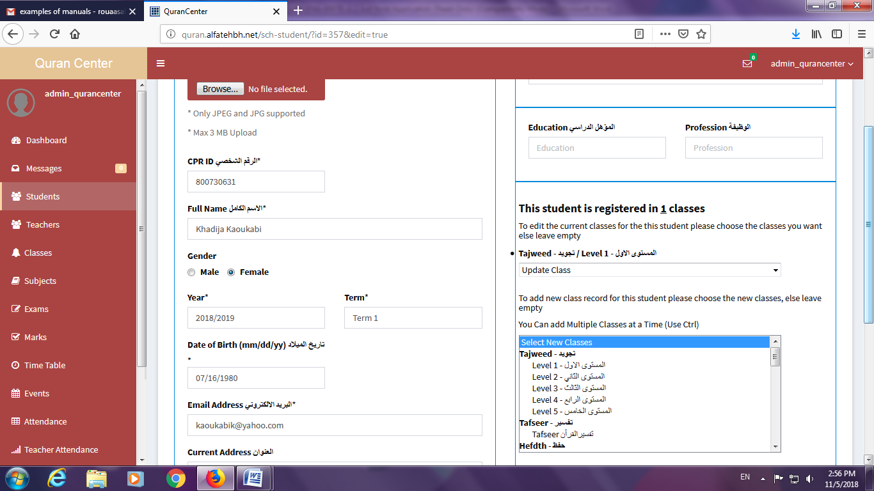

LOGOUT

Click on sign out to close the application.

